Autumn 2000

Class II Information Technology Engineer Examination (Morning)

Questions must be answered in accordance with the following:
Question Nos. | Q1 to Q80
Question Selection | All questions are compulsory
Examination Time | 9:30-12:00 150 minutes
Instructions:
1. Use an HB pencil.
If you need to change an answer, erase your previous answer completely and neatly. Wipe away any eraser debris.
2. Mark your answers in accordance with the instructions below. Your answers will not be graded if you fail to comply with the instructions. Do not mark or write on the answer sheet outside of the prescribed places.
(1) Examinee Number
Write your examinee number in the space provided, and mark the appropriate space below each digit.
(2) Date of Birth
Write your date of birth (in numbers) exactly as it is printed on your examination admission card, and mark the appropriate space below each digit.
How to Mark Your Answers
(3) Answers
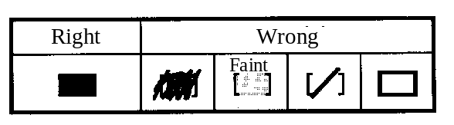
Select one answer (A through D) for each question.
Mark your answer as shown in the following sample
question.
[Sample Question] In which month is the Fall Information Technology Engineer Examination conducted?

a) 8 | b) 9 | c) 10 | d) 11

Since the correct answer is "C" (10), mark your answer sheet as follows:

[Sample Reply] a) b) c) d)
Do not open the exam booklet until instructed to do so.
Inquiries about the exam questions will not be answered)

Q1. What is the decimal value of the Binary Coded Decimal (BCD) value 100100010101?

a) –277 b) 915 c) 2325 d) 4425

Q2. Which of the following is equal to the hexadecimal value 2A)4C?

a) 2⁵+2³+2¹+2^{–2}+2^{–5}+2^{–6} b) 2⁵+2³+2¹+2^{–1}+2^{–4}+2^{–5}
c) 2⁶+2⁴+2²+2^{–2}+2^{–5}+2^{–6} d) 2⁶+2⁴+2²+2^{–1}+2^{–4}+2^{–5}

Q3. What is the fewest number of binary digits that are needed in order to represent all possible natural numbers which have five digits when represented as octal numbers?

a) 5 b) 10 c) 15 d) 20

Q4. According to the IEEE754 (1985) standard, the 32-bit floating point number format is as follows:

S | E（8-bit） | M（23-bit）
S: Sign, 1 bit
E: Exponent part, 8 bits
M: Mantissa part, 23 bits

Which of the following hexadecimal values expresses the mask bits used to extract the index? Here, “mask bits” refers to a bit pattern that is ANDed with the 32-bit floating-point value in order to extract the necessary information.

a) 0FF00000 b) 7F800000 c) FF000000 d) FF800000

Q5. Assume that “a” is the value produced by a 2-bit logical shift to the left executed on the contents of the 16-bit fixed-point register shown below, and “b” is the value produced by a 3-bit logical shift to the right executed on the contents of the 16-bit fixed-point register shown below. What multiple of “b” is the value of “a”? Assume that empty bits produced by the shift take a value of “0.”

0 | 0 | 0 | 0 | 0 | 0 | 0 | 1 | 0 | 1 | 0 | 0 | 0 | 0 | 0 | 0

a) 6 b) 12 c) 24 d) 32

Q6. Which of the following is a hexadecimal representation of the ASCII codes for the character string “STAR”? Assume that bit 8 of each character code is an even parity bit.

[Partial ASCII code table]
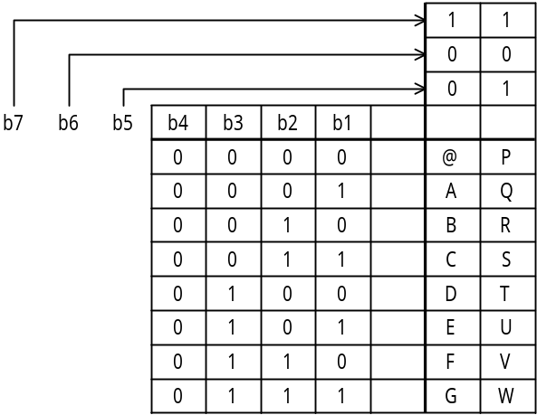

a) 1DA50C95 b) 53D441D2 c) 659541A5 d) D354C152

Q7. Which of the following floating-point operations causes a cancellation? Assume that the mantissa has three valid digits, and that the operation is performed on six digits.

a) 0.123×10²+0.124×10^{–2} b) 0.234×10^{5―}0.221×10²
c) 0.556×10⁶+0.552×10⁴ d) 0.556×10^{7―}0.552×10⁷

Q8. Two stack operations are defined as follows:
PUSH n : Pushes data (the integer n) onto the stack.
POP : Pops data out of the stack.
What is the result produced by performing the following series of stack operations on an empty stack?

PUSH 1 → PUSH 5 → POP → PUSH 7 → PUSH 6 → PUSH 4 → POP →
POP → PUSH 3

a) |  | b) |  | c) |  | d)
 | 1 |  | 3 |  | 3 |  | 6
 | 7 |  | 4 |  | 7 |  | 4
 | 3 |  | 6 |  | 1 |  | 3

Q9. “NOR” (negative logical sum) is one type of dyadic logical operation. Which of the four choices below is the correct result to be inserted in the line “x NOR y”?

x | 0 | 0 | 1 | 1
y | 0 | 1 | 0 | 1
x NOR y

a) | 0 | 0 | 0 | 1
b) | 0 | 1 | 1 | 0
c) | 1 | 0 | 0 | 0
d) | 1 | 1 | 1 | 0

Q10. The function eq (X, Y) returns a value of “1” if the parameters “X” and “Y” are equal, and a value of “0” if they are not. What are the necessary conditions for “1” to be returned when eq (eq (A, B), eq (B, C)) is called?

a) A = B and B = C
b) A = B or B = C
c) (A = B and B = C) or A = C
d) (A = B and B = C) or (A ≠ B and B ≠ C)

Q11. In the following logical circuit, when S = 1, R = 1, X = 0, and Y = 1, S is changed to “0” and then is changed back to “1.” What are the values of “X” and “Y” after this operation is performed? Here, 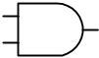 represents an AND (logical product) gate and 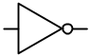 represents a NOT gate.

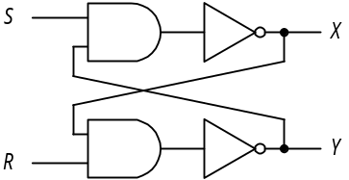

a) X = 0, Y = 0 b) X = 0, Y = 1 c) X = 1, Y = 0 d) X = 1, Y = 1

Q12. Repeating the following procedure four times divides a 16-bit unsigned fixed-point binary number into hexadecimal digits and then stores each digit in a stack, starting from the lowest digit. Which combination of phrases for “a” and “b” is correct? Here, the notation “xxxx₁₆” represents the hexadecimal value “xxxx.”

[Procedure]
(1)  → x
(2) Shift n  .
(3) Push x onto the stack.

 | a | B
a) | n AND 000F₁₆ | four bits to the left
b) | n AND 000F₁₆ | four bits to the right
c) | n AND FFF0₁₆ | four bits to the left
d) | n AND FFF0₁₆ | four bits to the right

Q13. The following procedure demonstrates a shell sort. When the data sequence “7, 2, 8, 3, 1, 9, 4, 5, 6” is sorted by repeating steps (1) through (4) below, how many times does step (3) have to be repeated? For the purposes of this question, the decimal fraction of any value enclosed in brackets below is truncated.

[Procedure]
(1) [Number of data elements÷3] → H.
(2) Break up the data sequence into sub- sequence, each of which is obtained by picking from the original sequence those elements which are H elements apart, and then sort elements in each sub- sequence by the insertion sort.
(3) [H÷3] → H
(4) If H is “0,” sorting is complete. If H is not “0,” return to step (2).

a) 2 b) 3 c) 4 d) 5

Q14. Assume that there is a table in which “n” unique data elements have been sorted in the ascending order. This table is then divided into “m” blocks, and the block that contains the target data is found by conducting a linear search of the last data element in each of the blocks. Next, the target data is found by conducting a linear search within the target block. What is the average number of searches that must be performed? Assume that m < n, and that the target data definitely exists in the table.

a) b) c) m ⁺ d) ⁺

Q15. An operation compares the values of adjacent elements in a sequence and then switches their positions if the smaller value is on the right. “One pass” is defined as the repeated execution of this operation for all elements in the data sequence, starting from the left and proceeding to the right. Given the data sequence shown below, what is the resulting sequence that is produced by two passes of this operation?

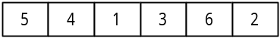

a) 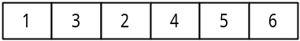 b) 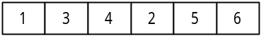

c) 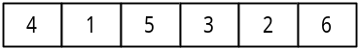 d) 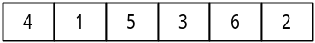

Q16. Which of the following statements applies to the clock that is used to control a processor?

a) If the processor has the same architecture, a higher clock frequency means that more instructions can be executed in a given unit of time.
b) The reciprocal of the clock frequency is equivalent to the number of instructions that can be executed within one second.
c) If no programs are running, the clock stops.
d) The series of processes from fetching an instruction to executing it can be performed within one clock cycle.

Q17. Assume a personal computer with a 200MHz processor. If the average instruction requires five clockcycles for execution, how many microseconds is the average instruction execution time for this personal computer?

a) 0.005 b) 0.025 c) 5 d) 25

Q18. Assuming a cache memory that has an access time that is 1/30 of the main memory access time, and a 95% hit rate, what multiple of the main storage unit access time is the effective memory access time?

a) 0.03 b) 0.08 c) 0.5 d) 0.95

Q19. The instruction “LOAD GR, B, AD” loads into general-purpose register GR the data that is stored in main memory at the address that is generated by adding the contents of base register B to AD)
Assuming the initial state shown in the diagram below, what will be the value in general-purpose register GR after the following instruction is executed?
LOAD GR, 1, 200

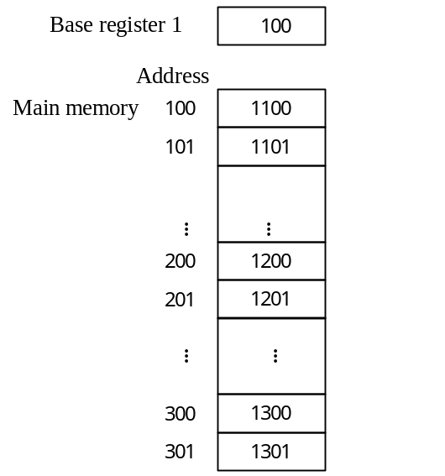

a) 1100 b) 1200 c) 1201 d) 1300

Q20. Which of the following error control methods for memory is used in automatic error correction functions?

a) Horizontal parity check b) Checksum
c) Check digit d) Hamming code

Q21. Which of the following statements concerning DVDs is true?

a) They can be read by a CD-ROM drive.
b) When using single-sided dual layer recording, they have a maximum storage capacity that is approximately four times that of a CD-ROM.
c) There are three types: read-only, recordable, and rewritable.
d) Data is recorded optically and magnetically.

Q22. For a hard disk drive with the specifications shown in the table, what is the approximate average time (in milliseconds) needed to completely retrieve 512 bytes (one sector) of data?

Data length | 512 | bytes/sector
Average search time | 6 | ms
Average seek time | 9 | ms
Data transfer rate | 128 | k bytes/second

a) 10 b) 16 c) 19 d) 55

Q23. A user wants to sequentially store 100,000 records (each consisting of 200 bytes) in a hard disk drive with the specifications shown in the table. How many cylinders are required if 10 records are recorded as one block? One block can span multiple sectors, but if the block length is not a multiple of 256, the excess portion of the last sector is left unused)

Number of tracks/cylinder | 19
Number of sectors/track | 40
Number of bytes/sector | 256

a) 103 b) 105 c) 106 d) 132

Q24. Given a PC card with a data transfer rate of 27MB/second, approximately how many 640 × 480-dot images can be transferred in one second? Assume that 24 bits are used to express each dot of an image, 1MB is 1024KB, and 1KB is 1024 bytes.

a) 3 b) 20 c) 30 d) 92

Q25. Which of the following statements concerning the features of USB is true?

a) USB utilizes a high-speed transfer method that is suited for data transfers that must be conducted in real-time, such as audio and video data transfers. USB permits devices to be connected in daisy-chain fashion or in tree fashion, and permits connection even in the absence of a personal computer acting as host.
b) Peripheral devices are connected through a personal computer acting as host. USB supports multiple data transfer modes; generally, a printer or scanner uses full-speed mode, and a keyboard or mouse uses low-speed mode.
c) USB is a serial interface that was originally designed for connecting modems, but is now used for connecting peripheral devices to a personal computer.
d) USB is a parallel interface that connects hard disks, laser printers and other peripheral devices to small-scale computers, including personal computers.

Q26. Which of the following is the best index of laser printer performance?

a) Number of dots per inch (2.54 cm) and number of pages that can be printed per minute
b) Number of dots (in the vertical and horizontal directions) used to print one character, and the number of characters that can be printed per second
c) The spacing between lines and the number of lines that can be printed per second
d) The types of characters that can be printed and the number of characters that can be printed per second

Q27. Which of the following could be the cause of a program interrupt?

a) An input/output operation was completed.
b) A hardware failure occurred.
c) An overflow occurred as the result of an operation in the program.
d) The program timed out.

Q28. Which of the following statements concerning page-swapping in virtual memory management describes the LRU control method?

a) A reference flag and a change flag are added to each page for management purposes, and priority is given to swapping pages that have not been referenced or changed.
b) All pages in the main memory have the same probability of being selected for swapping.
c) The page which has not been referred to for the longest time is swapped.
d) The page which has resided for the longest time in the main memory is swapped.

Q29. Which of the following is used for mutual exclusion?

a) Contention b) Semaphores
c) Check points d) Hash

Q30. What is the yardstick that is used to evaluate the ability of a system to process jobs within a given unit of time?

a) MIPS value b) Response time
c) Throughput d) Turnaround time

Q31. Which of the following explanations of how memory usage is calculated in order to estimate performance is correct?

a) Memory usage is calculated for each of the OS space and the user space on the basis of the total memory required and the amount of memory actually installed.
b) Memory usage is calculated on the basis of the weighted average number of dynamic steps and the amount of data processed by the system as a whole.
c) Memory usage is calculated for each processing model on the basis of the length of the messages that flow in all circuits and the volume of communications.
d) Memory usage is calculated for each processing model on the basis of the input/output record size and the number of accesses.

Q32. The following table lists the priority of three tasks and the amount of time that each task occupies the CPU and an I/O device when each task is executed independently. Assuming an OS that schedules tasks according to their priority, what is the total number of milliseconds that task C is in the executable state, starting from the point when all three tasks become executable until task C ends? Assume that the I/O for all tasks can be performed in parallel, and that OS overhead is negligible.

Task | Priority | Time occupied for individual task execution (unit: ms)
Task | Priority | CPU → I/O → CPU → I/O → CPU
A | High | 4 | 4 | 3 | 5 | 3
B | Medium | 2 | 6 | 3 | 6 | 2
C | Low | 2 | 5 | 3 | 4 | 1

a) 2 b) 5 c) 8 d) 11

Q33. Upon analyzing the turnaround time for a given job, it was found that CPU time accounted for 2/3 of 1,350 seconds, and I/O accounted for the remainder. After taking into account an increase in the amount of data to be processed and improved performance, it is expected that one year later the CPU time will be 80% of what it was the year before. Due to the increase in the amount of data to be processed, it is also expected that the I/O time will be 120% of what it was the year before. What will the turnaround time for this job be after one year? Assume that idle time, overhead, etc., are negligible.

a) 1,095 b) 1,260 c) 1,500 d) 1,665

Q34. Which of the following statements concerning the spooling function is true?

a) If the CPU becomes idle due to the execution of an I/O instruction while executing a given task, the spooling function allocates the CPU to another task.
b) The spooling function temporarily interrupts the program that is being executed and passes control to the control program.
c) The spooling function performs transfers between main memory and slow I/O devices through auxiliary memory, improving the overall throughput of the system.
d) The spooling function prepares a buffer pool that contains multiple buffers and shortens access times by increasing the probability that a given buffer in main memory will be accessed.

Q35. Which term describes the adjustment of addresses in a program to conform with the location in memory where a program is loaded when a program is loaded and then executed?

a) Virtual memory b) Optimization
c) Relocation d) Linking

Q36. In some circumstances, a program can be still running when it is called again by another program. Which of the following describes the called program if that program runs correctly in this situation?

a) Recursive b) Reusable
c) Reentrant d) Relocatable

Q37. Which of the following values is the closest to the availability of the entire system configuration shown in the diagram below? Assume that the availability of devices A and C is “0.9,” and the availability of devices B and D is “0.8.”

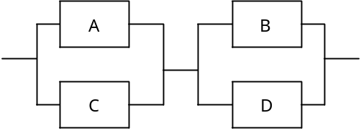

a) 0.72 b) 0.92 c) 0.93 d) 0.95

Q38. In which of the following control methods does the terminal that is attempting to send a message first issue a send request and confirm that the other terminal is ready to receive, and then send the message?

a) Contention mode b) Token-bus method
c) Token-ring method d) Polling method

Q39. Which device connects LANs to each other in the physical layer of the OSI basic reference model?

a) Gateway b) Bridge
c) Repeater d) Router

Q40. In the OSI basic reference model, which layer provides highly reliable, transparent, end-to-end data transfers between terminals by selecting an error detection function and recovery function in accordance with the transmission quality of the network being used?

a) Session layer b) Transport layer
c) Network layer d) Presentation layer

Q41. A system transfers data between headquarters and the plant over a dedicated line. In this system, 256 bytes of data are used for one slip; data is sent in groups of ten slips, along with an 80-byte header. An average of 10,800 slips are generated per hour. Assuming the line speed is 9,600bps, what is the line usage rate (as a percentage)?

a) 8.25 b) 64 c) 66 d) 84

Q42. Of the LAN standards defined in IEEE 802.3, which has a bus topology, has a transmission speed of 10Mbps, uses the baseband transmission method, and permits use of segments up to 185m long?

a) 100BASE-T b) 10BASE-T c) 10BASE2 d) 10BASE5

Q43. What is the means that is used in a WWW server to pass data that is input from a browser to an application program?

a) CGI b) HTTP c) MIME d) URL

Q44. Select the correct combination of terms for the following file organization methods:

 | a | b | C
Features | - Consists of a group of records called “members.”  - Suitable for program libraries.  - Has a directory area. | - Permits rapid access to a record that has a specific key value.  - The file occasionally needs to be re-organized.  - Records can be easily added or deleted. | - Permits rapid access to a record that has a specific key value.  - Generates synonyms.  - Uses media inefficiently.  - Records can be easily added or deleted.

 | a | b | c
a) | Partitioned organization | Indexed organization | Direct organization
b) | Partitioned organization | Direct organization | Sequential organization
c) | Indexed organization | Sequential organization | Partitioned organization
d) | Indexed organization | Direct organization | Partitioned organization

Q45. Which of the following explanations of schemas in a data base system is correct?

a) A schema is a virtual table from the viewpoint of the user, not an actual table.
b) A schema is a collection of data definitions, including data characteristics, formats, and relationships with other data.
c) “Schema” is a general term for data base operations, including data insertion, updating, deleting, and retrieval.
d) “Schema” is a general term for various restrictions and conditions that are needed in order to keep a data base in a perfect condition.

Q46. The diagram below depicts a directory structure that contains multiple directories named “A” and “B”. Select the final current directory after the current directory has been moved as follows: \A\B → .. → ..\B → .\A
Assume that the directory specification method described below is used)

[Directory specification method]
(1) When the specification begins with “\”, it is assumed that the root directory is specified to the left of the symbol.
(2) A directory is specified by a series of directory names in the path, starting from the highest directory and delimited by the “\” symbol, as follows: “directory-name\...\directory-name”
(3) The current directory is represented by “.”.
(4) The directory one level higher than the current directory is represented by “..”

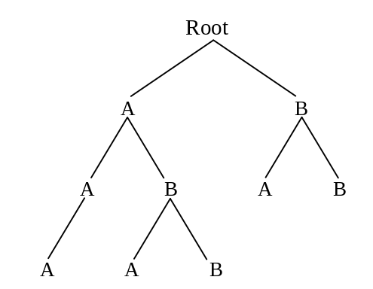

a) \A b) \A\A c) \A\B\A d) \B\A

Comment: The special character “\” is used in place of “/” in personal computers in Japan. This “\” should be replaced by “/” or the currency symbol corresponding to the same binary code.

Q47. In a spreadsheet program, the following calculations are set up in each cell. If the value “2” is input in cell A1, what value appears in cell B3? Assume that when a value is input in a cell, the other cells are recalculated immediately.

 | A | B
1 |  | A1
2 | A1+1 | A2+B1
3 | A2+1 | A3+B2

a) 4 b) 5 c) 9 d) 10

Q48. Select the values to be produced when the contents of the following spreadsheet are written out in the CSV format. Assume that the line feed code “^{C}_{R}” is used as the delimiter between records, that the calculations in each cell are recalculated immediately, and that the calculated results are written out.

 | A | B | C
1 | 2 | 7 | A1+B2
2 | 6 | 4 | A2+B1
3 | A1+A2 | B1+B2 | C2+B3

a) 2 , 6 , 8 ^{C}_{R} 7 , 4 , 11 ^{C}_{R} 6 , 13 , 24 ^{C}_{R}
b) 2 , 6 , 8 ^{C}_{R} 7 , 4 , 11 ^{C}_{R} 9 , 10 , 19 ^{C}_{R}
c) 2 , 7 , 6 ^{C}_{R} 6 , 4 , 13 ^{C}_{R} 8 , 11 , 24 ^{C}_{R}
d) 2 , 7 , 9 ^{C}_{R} 6 , 4 , 10 ^{C}_{R} 8 , 11 , 19 ^{C}_{R}

Q49. When an error occurs in data base operations, which of the following is the error recovery process that is performed in order to restore the data base to the state it was in before the start of the transaction?

a) Checkpoint b) Database dump
c) Roll back d) Roll forward

Q50. Which of the following explanations of log files in a DBMS is correct?

a) A log file is a file of updated data in memory that is written onto disk regularly in order to reduce the amount of time needed for database recovery process when the system goes down.
b) A log file is an identical copy of the data in a data base that is written into another data base on a different disk or at a different site in order to permit the system to run immediately even if a disk fails.
c) A log file is a copy of the contents of an individual disk in a data base that permits recovery of the data base in the event that a disk fails.
d) A log file is a record of updates made to a data base, and contains both the pre-update and post-update data from this file is used in data base recovery process.

Q51. Select the normalized structure for the following order table:

Order No. | Order date | Customer | Product | Quantity | Unit price | Total amount
1 | 00/10/01 | A | S | 3 | 1,000 | 4,900
1 | 00/10/01 | A | T | 2 | 950 | 4,900
2 | 00/10/01 | B | S | 1 | 1,000 | 22,000
2 | 00/10/01 | B | U | 10 | 1,200 | 22,000
2 | 00/10/01 | B | V | 5 | 1,800 | 22,000
3 | 00/10/02 | B | T | 8 | 950 | 7,600
4 | 00/10/02 | C | U | 25 | 1,200 | 30,000
… | … | … | … | … | … | …

a) | Order No. | Order date | Customer | Total amount |  | Order No. | Product | Quantity |  | Product | Unit price

b) | Order No. | Order date | Customer | Total amount |  | Customer | Product | Quantity |  | Product | Unit price

c) | Order No. | Order date | Customer | Total amount |  | Order date | Product | Quantity |  | Product | Unit price

d) | Order No. | Order date | Customer | Total amount |  | Product | Quantity |  | Product | Unit price

Q52. Which of the following is the best explanation of “reverse engineering” in regards to software?

a) Extracting the design specifications from installed software and using them for software development.
b) Designing software in the sequence of “output, processing, and input.”
c) Implementing software functions in hardware.
d) Selecting the development language and development tools on the basis of the content of the processing to be performed by the software.

Q53. Which of the following statements concerning object-oriented programming is true?

a) An object is a template for a class.
b) “Encapsulation” refers to the creation of a library of classes.
c) A class always has at least one instance.
d) A class can inherit attributes and methods from its parent class.

Q54. The diagram below depicts a program that consists of five functions, A through E. The table describes the interfaces between these functions. Each interface between two functions is numbered in the diagram, and these numbers correspond to the “No.” column in the table. In addition, functions A, D, and E all reference a special data area. What type of module connection relationship exists between functions A and E?

4
4
3
2
1
Special
data area
B
D
C
E
A
Table Interfaces between Functions
No. | Parameters | Return value
1 | Contents of data items | Contents of data items
2 | Contents of data items | Contents of data items
3 | Function code | None
4 | None | List

Fig. Program Configuration

a) Common connection b) Data connection
c) Content connection d) None (indirect connection)

Q55. In a given system, a value is calculated from the input data in accordance with fixed rules. The input data is checked by determining a check character on the basis of this calculated value, and then adding that check character to the end of the data)
When the following rules are used, which is the correct check character that is added to the four-digit numeric data “2131”?

[Rules]
(1) The following coefficients are assigned to each digit of the input data: 4, 3, 2, 1.
(2) The value digit is multiplied by the assigned coefficient of each and the products are summed over the digits.
(3) The value that was derived in (2) is divided by “11” in order to derive the remainder.
(4) The remainder that was derived in (3) becomes the check character. If the remainder is “10,” “X” is the check character.

a) 1 b) 3 c) 5 d) 7

Q56. Which of the following statements concerning the control structure of a program is true?

a) “A loop with the termination condition at the bottom” evaluates the end condition at the start of the loop process.
b) “A two-way branch” selects whether to return to the previous process or to proceed to the next process.
c) “A multi-way branch” starts multiple processes in parallel.
d) “A loop with the termination condition at the top” sometimes results in the loop process not being performed at all.

Q57. One item of a record in a sales file is a process category in, and the process to be performed depends on this process category. The ratio of appearances of each processing class is already known for all sales data. Which of the following statements concerning the comparison counts for determining the process category is true?

a) The overall number of comparisons is reduced by using the value of the category with an intermediate ratio of appearance first.
b) The overall number of comparisons is reduced by using the value of the category with the highest ratio of appearance first.
c) The overall number of comparisons is reduced by using the value of the category with the lowest ratio of appearance first.
d) The overall number of comparisons does not change regardless of the order of evaluation.

Q58. Which is the correct flowchart for using a sentinel to find x in the data stored in an array A[1] to A[n]?

a) b)
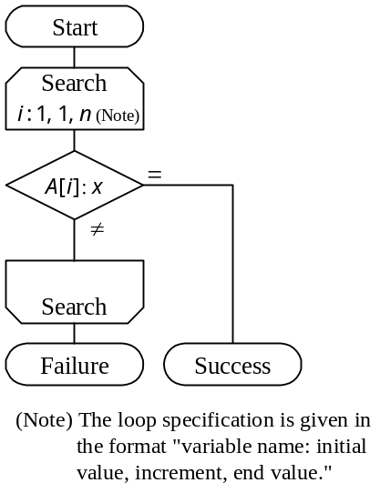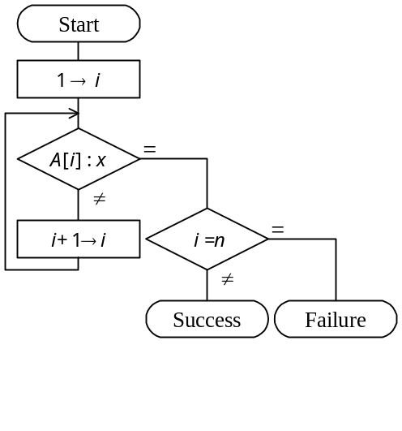

c) d)
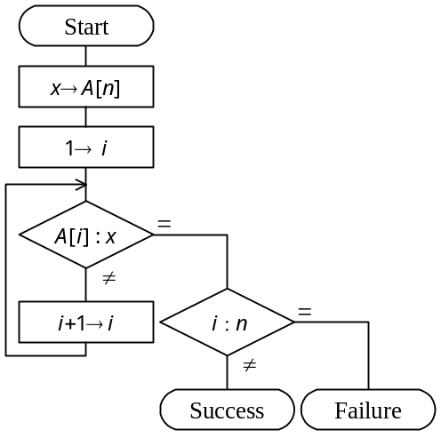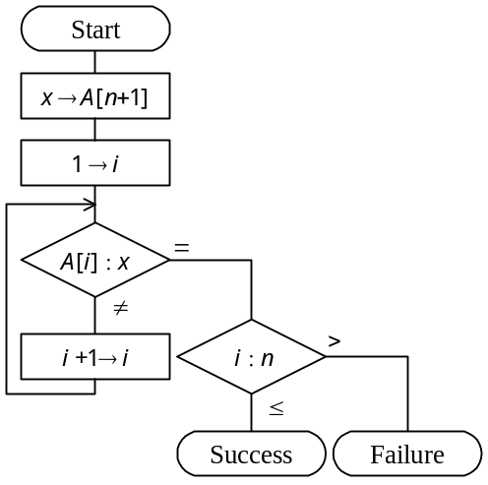

Q59. The following flowchart describes a process for converting a decimal number j (0 < j < 100) to a binary number. The binary number is stored in elements 1 through 8 of the array BIN, starting from the least significant digit. What processing should occur in the spaces labeled "a" and "b" in the flowchart? Here, "j div 2" returns the integer portion of the quotient of j divided by 2, and "j mod 2" returns the remainder of j divided by 2.

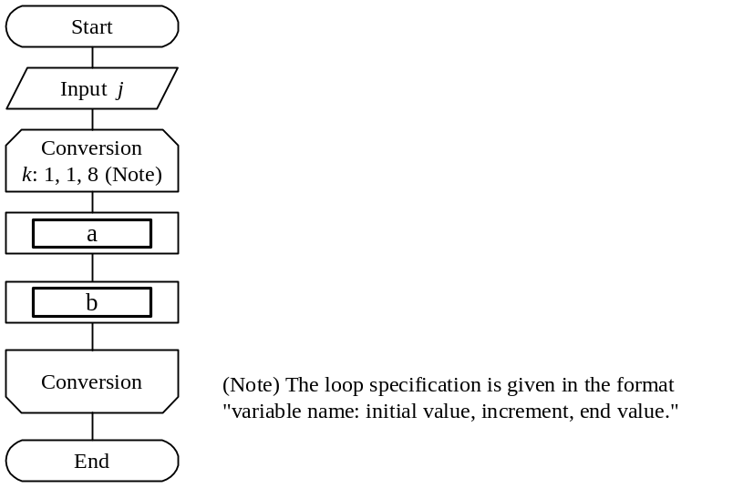

 | a | b
a) | j div 2 → j | j mod 2 → BIN [k]
b) | j div 2 → BIN [k] | j mod 2 → j
c) | j mod 2 → j | j div 2 → BIN [k]
d) | j mod 2 → BIN [k] | j div 2 → j

Comment: NISHIN (meaning "binary") is used for BIN (short for "binary") in the Japanese version.

Q60. "A" and "B" below are both algorithms for determining the value of the function Y = F(X) for X = 0 to 1 in steps of 0.0001. How will "A" compare with "B" in terms of the computation precision and computation time when implemented on a real computer?

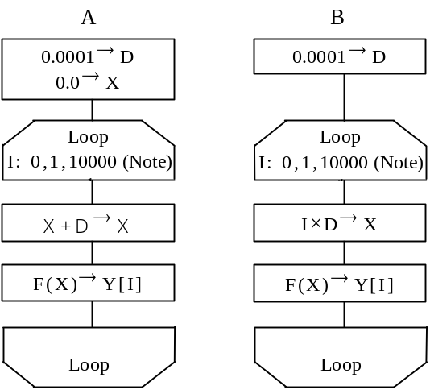
(Note) The loop specification is given in the
format "variable name: initial value,
increment, end value."

 | Computation precision | Computation time
a) | Higher | Longer
b) | Higher | Shorter
c) | Lower | Longer
d) | Lower | Shorter

Q61. If the system development process is divided into definition of requirements, high-level design, low-level design, program design, and programming, which of the following tests is used primarily for verification of the high-level design?

a) Operations test b) Integration test
c) System test d) Unit test

Comments: “High-level design” and “low-level design” are often called “external design,” “internal design” respectively in Japan.

Q62. Which of the following is a suitable testcase to test the logic shown in the diagram by means of branch coverage test?
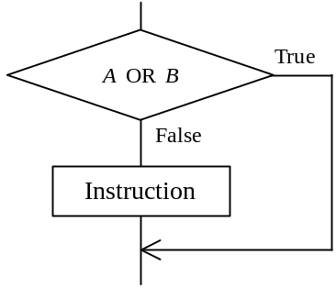

a) b) c) d)
A | B |  | A | B |  | A | B |  | A | B
False | True |  | False | True |  | False | False |  | False | True
 |  |  | True | False |  | True | True |  | True | False
 |  |  |  |  |  |  |  |  | True | True

Q63. Which of the following is a proper description of a special feature of the function point method, a method that is used to estimate workload required for software development?

a) The function point method identifies the products to be developed and the tasks to be performed for them, and estimates the workload for each product according to a certain criteria.
b) The function point method is difficult to apply if no similar system has been developed in the past.
c) The function point method uses standard values for counting the lines of code (LOC) and converting them to workload, making it comparatively easy to calculate the required development workload.
d) The function point method is easy for users to understand because it uses as the unit of estimation the count of the screens and reports that users can see.

Q64. Based on the information shown below, what is the cost of production of the product, in millions of yen?

Unit: 1 million Yen
Indirect production cost | 60 | Direct costs | 100 | Direct labor costs | 120
Direct material cost | 200 | Marketing costs | 90 | General administrative costs | 30
Product selling price | 900

a) 360 b) 420 c) 480 d) 510
Comment: ‘yen’ is the Japanese currency. It should be replaced by US currency or the currency used in your country.

Q65. A certain product has been experiencing gradual increases in its purchase price. There was inventory of this product remaining at the end of the previous quarter, and there has been several inventory turns in the current quarter. When evaluating the inventory on hand at the end of the current quarter, which method of evaluation will generally yield the highest appraised value?

a) Last in, first out method b) Moving average method
c) First in, first out method d) Total average method

Q66. Which of the following is the best description of EOS(Electronic Ordering System)?

a) EOS is a system based on EDI, makes standard agreements concerning transactions between enterprises, and support processing for procurement to manufacturing, shipping, consumption, and disposal.
b) EOS is a system for accepting customer orders over the Internet.
c) EOS is a computer system for retailers that collects and manages information in real-time as products are sold so that stores can know how many of which products were sold when.
d) EOS is an online ordering system that is designed to improve the accuracy and efficiency of ordering operations.

Q67. Which of the following is a suitable example of the application of ABC analysis?

a) Divide a region into three areas according to a certain objective, select an opinion leader in each area, and conduct repeated surveys in order to learn about trends and conditions in each area.
b) Sort separate products in descending order of their selling prices or gross profits, divide the cumulative ratios into three ranks, and conduct a product analysis in order to learn which products sell well.
c) After dividing a region into a grid along longitudinal and latitudinal lines, collect data on population, purchasing power, etc., for each cell in the grid, and perform an even more precise regional analysis.
d) Based on sales data from receipts, analyze the combinations of products purchased by customers, etc.

Q68. Which type of bar graph has specific interval widths and boundary values between intervals, and expresses the distribution of the counts of the measured data elements?

a) Scatter diagram b) Cause and effect diagram (fish bone diagram)
c) Pareto diagram d) Histogram

Q69. Which of the following statements about correlation coefficients is true?

a) When there is complete positive correlation, the correlation coefficient is "+1."
b) When there is a linear relationship in the amount of change, the correlation coefficient is "0."
c) When there is a nonlinear relationship in the amount of change, the correlation coefficient is always negative.
d) When there is no correlation, the correlation coefficient is "-1."

Q70. When four people are picked at random, what is the probability that at least two of the people will have been born in the same month? Assume that the probability of birth is equal for the all months.

a) 0.25 b) 0.43 c) 0.57 d) 0.62
Q71. Which of the following statements about standard deviation is true?

a) The standard deviation of all data plus constant "a" is equal to the original standard deviation plus constant "a)"
b) The standard deviation of all data plus constant "a" is equal to the original standard deviation multiplied by "a)"
c) The standard deviation of all data multiplied by two is equal to the original standard deviation divided by two.
d) The standard deviation of all data multiplied by two is equal to the original standard deviation multiplied by two.

Q72. Which of the following descriptions of Shift JIS Code is correct?

a) Shift JIS Code consists of 8-bit codes and can be used to represent 256 characters.
b) Shift JIS Code is a code system that was adopted as the BMP (Basic Multilingual Plane) in ISO/IEC 10646, and was created for the purpose of facilitating data exchanges between personal computers.
c) Shift JIS Code is a standard for kanji codes specified in JIS X 0208, and consists of two-byte codes that are used to represent single characters. Each byte has a value ranging "21" and "7E" (hexadecimal). The codes are divided into Level 1 and Level 2 according to their frequency of usage.
- Shift JIS Code is a conversion of the JIS kanji code system that can identify one-byte alphanumeric and kana codes intermixed with two-byte kanji codes.

Comment: This question is not applicable to countries other than Japan. Therefore, it is recommended to delete this or replace this by an appropriate question concerning information interchange code in your country or by a question on unicode which is an ISO standard to allow the use of two bytes for each characters so that character sets in different (non-western) countries can be represented.

Q73. Which of the following charts or diagrams is used to express work schedules and execution?

a) SD chart b) Venn diagram
c) Gantt chart d) Decision tree

Q74. Which of the following statements concerning system audits as stipulated in "System Audit Standards" is true?

a) A system auditor conducts a comprehensive inspection and evaluation of an information system from an independent and objective standpoint, and then reports the results to the head of the organization.
b) A system auditor conducts tests to determine whether processing is performed as planned, and authorizes release of the system.
c) A system auditor evaluates the performance of a system and reports the results to the users of the system.
d) After comprehensive testing of the information system is completed, a system auditor evaluates the system from the aspect of security, such as functions designed to prevent illegal access, and then endorses its transfer to the user.

Q75. Which of the following statements concerning measures to protect against computer viruses is true?

a) A disk infected with a virus should be reformatted logically in order to delete the virus from each infected file.
b) When installing software from rewritable media, the software should be installed without using any write-protection measures.
c) Before installing software, you should first confirm that the computer itself has not been infected with a virus.
d) Because anti-virus measures are the responsibility of the individual even in a multi-user system, there is no need to designate someone to be responsible for anti-virus measures.

Q76. In a method that verifies users by comparing their input password with their registered password, which of the following is a measure to prevent the theft of registered passwords by illegally accessing the password file?

a) Register the hash value of the user ID corresponding to each password, then use the hash function to convert the user ID that is input during verification and compare the registered password with the input password.
b) Register the password as is, then use the hash function to convert both the password that was input for verification and the registered password, and then compare the results.
c) Register the password as is, and compare that password with the password that was input for verification.
d) Convert the password to a hash value and then register the hash value; when a password is input for verification, convert that password to a hash value with the hash function and then compare the hash values.

Q77. Assuming the number of characters in the character set that is used for a password as "M" and the number of characters in a password as "n," which formula derives the number of passwords "P" that can be set?
a) | P = M ^{n} | b) | P = | M!
 |  |  |  | (M–n)!

c) | P = { | M! | }× | 1 |  | d) | P ={ | (M+n–1)! | }× | 1
c) | P = { | (M–n)! | }× | n! |  | d) | P ={ | (M–1)! | }× | n!

Q78. Which of the following statements concerning copyrights is true?

a) All the phases of development, from analysis to production, of Company M's business program were undertaken by Company N. The original copyright holder of this program is Company M.
b) Even just using the idea of an existing program to produce an entirely new program for the same purpose is an infringement of the copyright on the existing program.
c) Copyrights and author personal rights can be transferred to another person.
- In Japan, duplication and distribution of copyrighted material without permission is an infringement of copyright, even if the copyright symbol is not clearly indicated on the copyrighted material.
Comment: Statement D should be changed to reflect the law or regulation in your country.
Q79. Which of the following statements concerning a comparison of patents and copyrights is true?

a) In the case of patents, an original invention can still infringe on another party's rights if that party acquired those rights earlier, while in the case of copyrights, an original work cannot infringe on another party's rights, even if the result of that work is identical to the existing work.
b) Patents protect ideas that are new or progressive and that use natural laws, while copyrights protect programming languages and protocols that contain creative elements.
c) A patent right is secured when a patent is submitted to Japan’s Patent Office, checked and registered, but a copyright to a program is secured only when the program is registered with the registration agency specified by the Director General of the Agency for Cultural Affairs.
- The objective of patent laws and copyright laws is to contribute to the advancement of industry by protecting rights.
Comment: Statement C should be changed to reflect the way how patent rights accrue in your country.

Q80. In which of the following types of employment arrangements does the worker not conclude an employment contract with the company at which he works?

a) Non-regular employee b) Part-timer
c) Loan employee d) Temporary employee
Comment: The classification of the above employees may not be applicable to your country.

